**Project 0: Familiarity with UNIX/Linux**

Kyungchan Im

Grand Canyon University

Course number: CST - 315

Professor Ricardo Citro

Due Jan 22, 2023

**Project 0: Familiarity with UNIX/Linux**

This project is an introduction to the operating system and familiarization with UNIX/Linux. There are three objectives for this project: to demonstrate familiarity with the basic principles of UNIX/Linux, to verify proper installation of UNIX/Linux on a computer, and to review UNIX/Linux shell scripting. The operating system has many features that can perform various tasks and provide convenience for programmers and users. In part one, we will analyze what happens "behind the scenes" inside the operating system and demonstrate how to compile a C++ file. Part two will involve reviewing UNIX/Linux shell scripting. There will be ten commands to test, and each command will be analyzed in detail.

**PART 1: Linux Introduction**

1) Change in directory

When the Linux cd command is used, the shell looks up the directory in which the command was issued and searches for the directory specified. The directory is then changed to the specified directory. The shell then verifies that the requested directory exists, and if it does, the shell changes the working directory to the specified directory that is directed from the user. If the requested directory does not exist, the shell will inform the user that the directory could not be found. In the background, the pointer is pointing to one register address and when the user requests a jump to another register address, the OS system checks if the register address is valid or exists. If it is valid and exist, the pointer points to that register address.

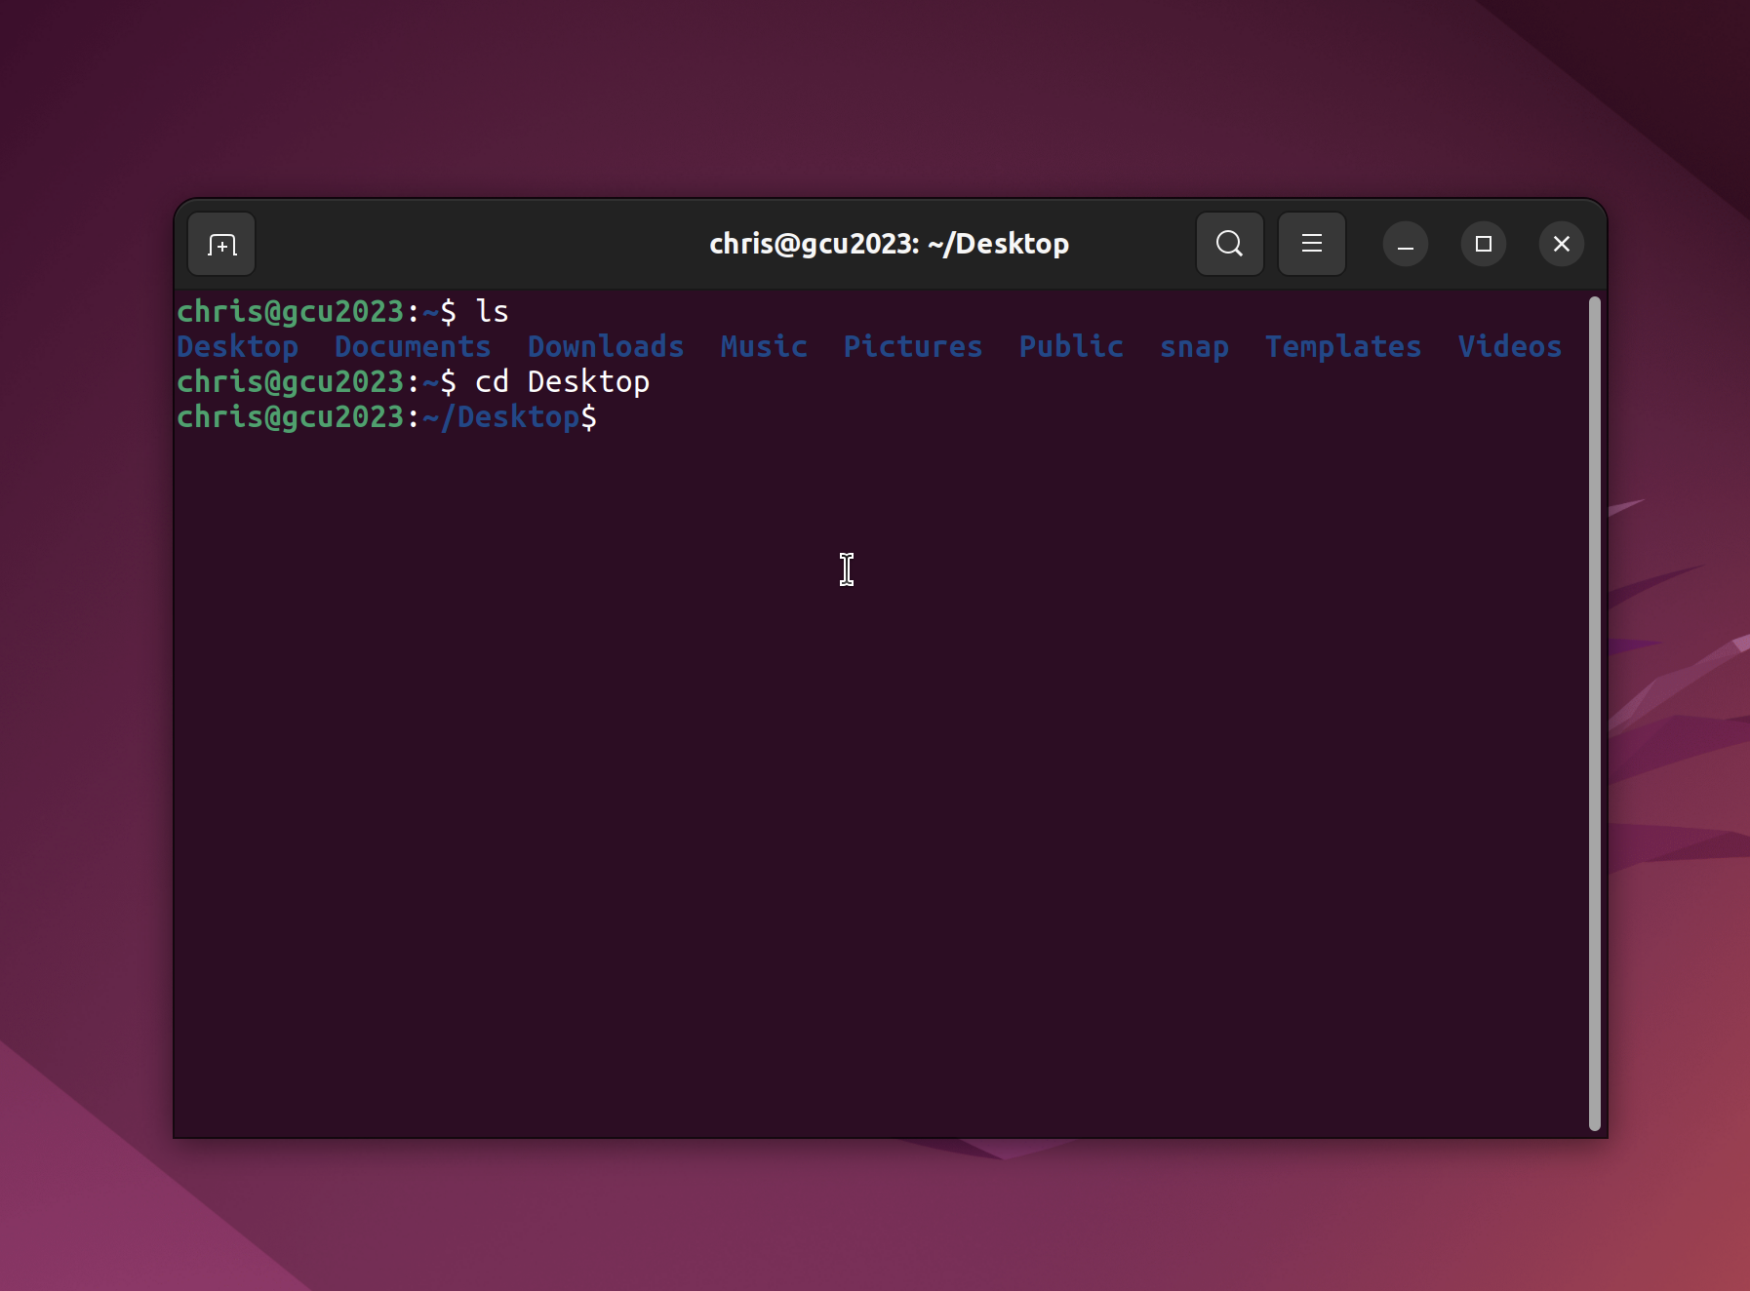

2) Kill the process

The Linux kill command allows users to terminate a process by sending a signal to the kernel. The process ID must be provided for the operating system to recognize which process should be terminated. If no process ID is specified, then the operating system will perform the default action. After the command is entered, the signal is sent to the kernel, which then searches the memory for the process ID and terminates it. In detail, the operating system sends the signals to the handler in kernel and performs the task. Once the task is done, the signal handler returns the signal back to the operating system and the process management system performs the kill task.

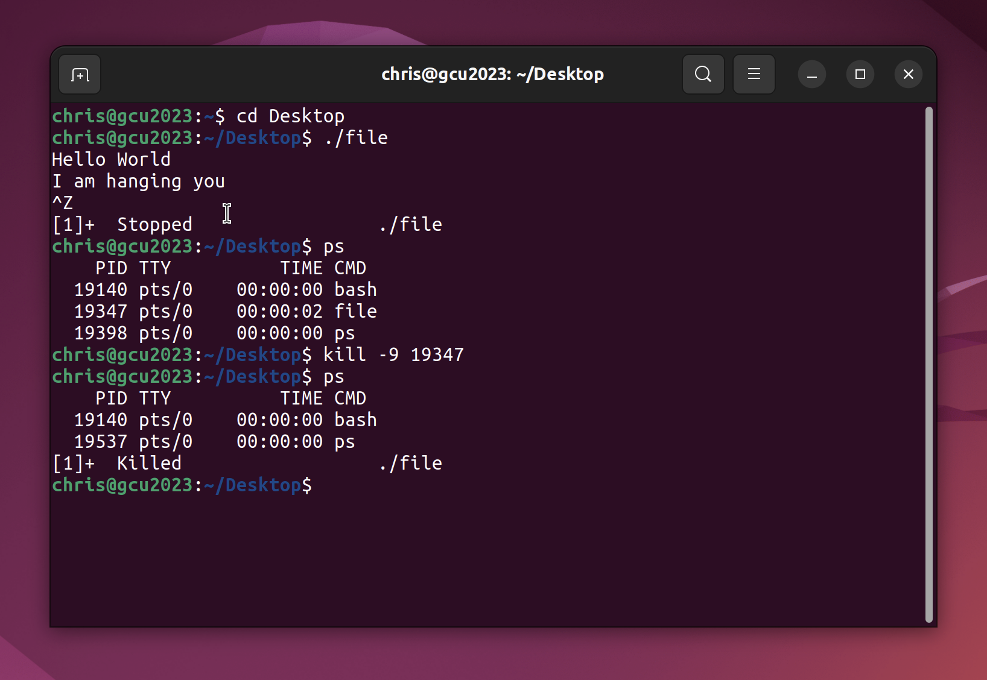

3) Create a text file

The Linux cat command allows users to create a text file and write it on the terminal shell until the user interrupts the process. When users enter cat filename.txt, the cursor is placed on the next line instead of returning to the terminal prompt. Users can write a text by typing it, and once they are done with writing a text, they can terminate it by giving the terminate command of Ctrl + D. In behind the scenes, when the cat command is given, operating system generate the file in the current directory. The register pointer is pointing the current location address in the memory and operating system generates the file. Once the file is generated, user writes the text, then the operating system manages the given prompt and operate it by allocating the text characters in right registry location.

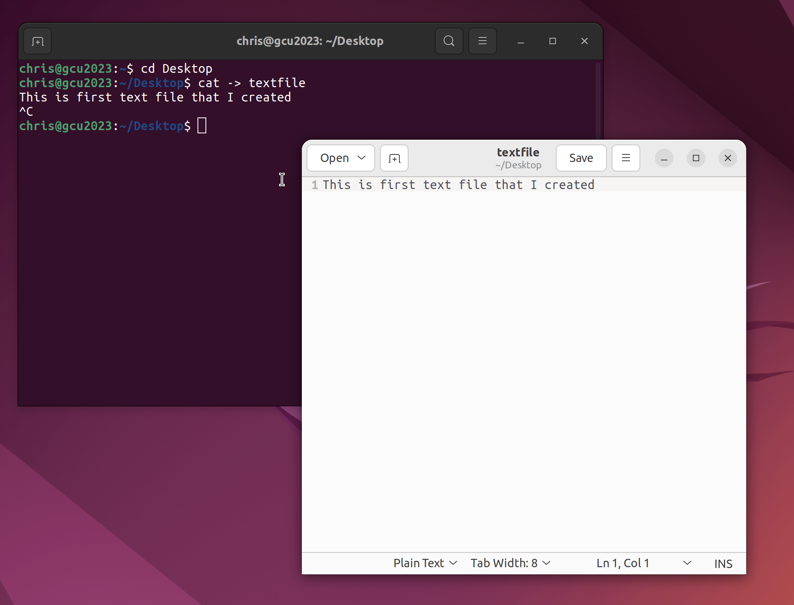

4) Accessing I/O devices

The operating system accesses I/O devices by sending a request to the device driver, which interprets the request and translates it into commands that the I/O device can understand. The device driver then sends the commands to the I/O device, which performs the requested operation and sends a response back to the device driver. The device driver translates the response into a format that the operating system can understand, which the operating system then processes and sends back to the user. Within a scope for this process, operating system handles the I/O device interruption signal generated by the hardware as well.

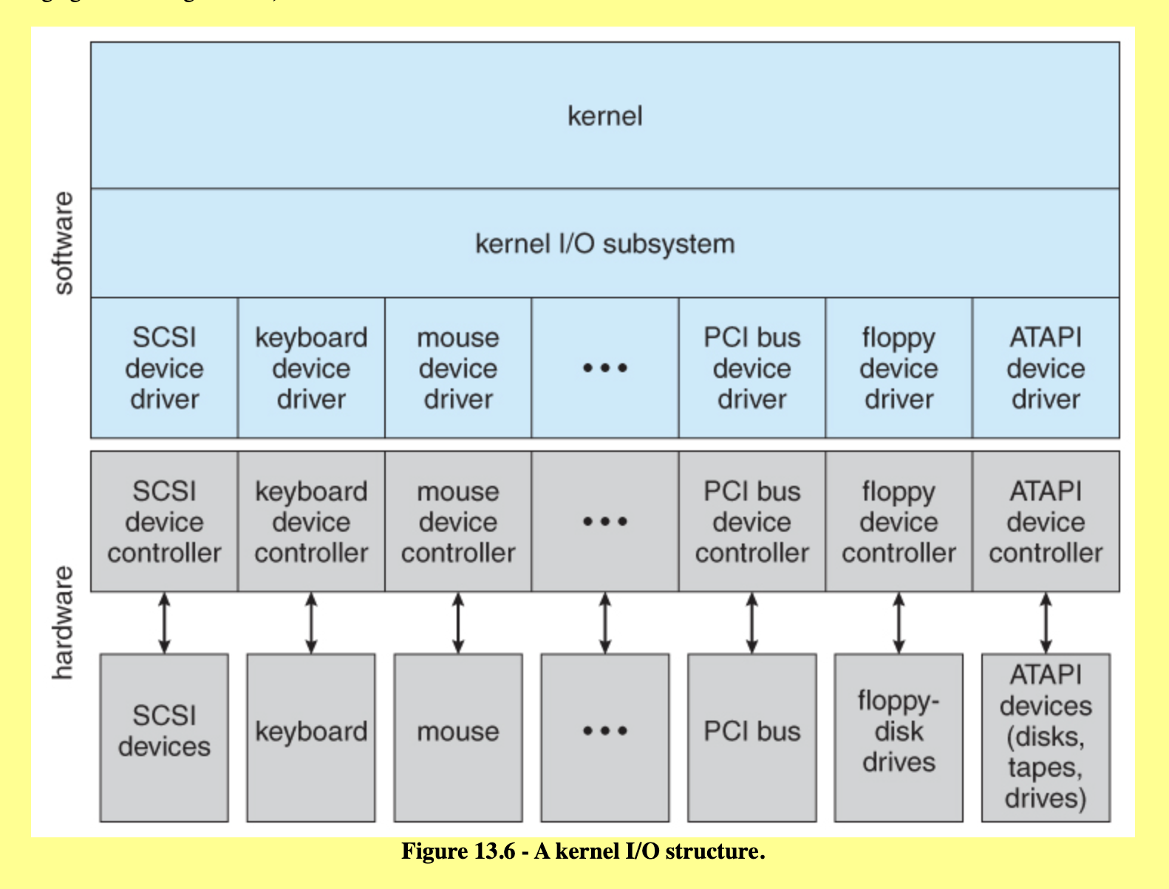

5) Shutting down the computer

When a user initiates a shut down, the operating system sends signals to all running applications and processes to close and save their data. It then flushes any remaining data from memory to the hard drive and powers off the computer. The operating system uses power management functions to initiate the shutdown process. In behind the scenes, the operating system sends the signal to the computer to access the syscall registry and the execute the shutting down process.

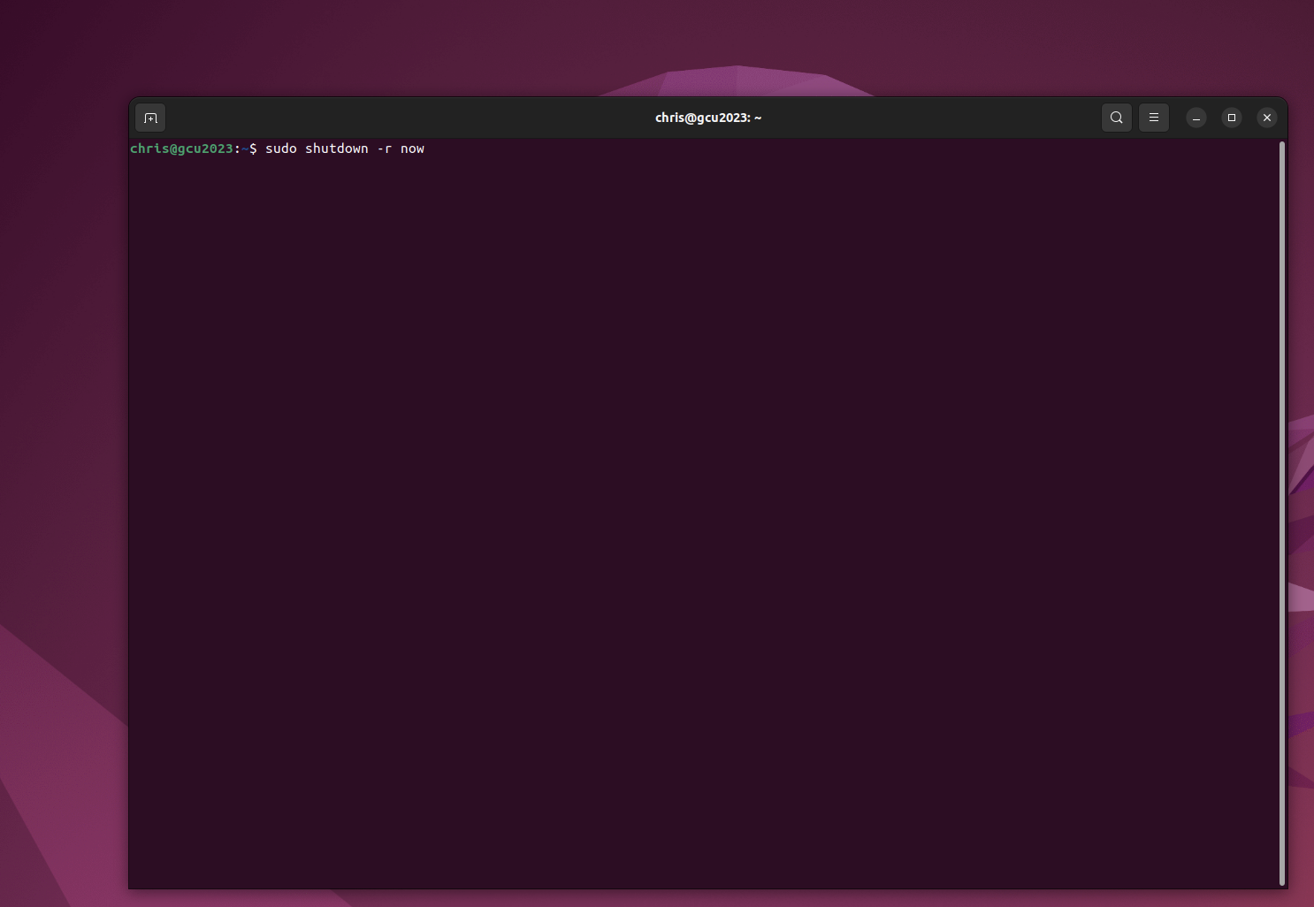

**Linux Installation**

In order to run a Linux on a MacBook, it is required to have a cross over platform or a virtual environment. I used UTM for running a virtual environment. Once the UTM application is running, there is an option to download Ubuntu 22.04 version with arm64 architecture iso. There are some steps required to completely implement the Linux on the UTM. Once the iso file is running on the UTM, installation process initiates. Also, GUI for Linux desktop is necessary to install, so further process is required to finish installing the Linux on MacBook system.

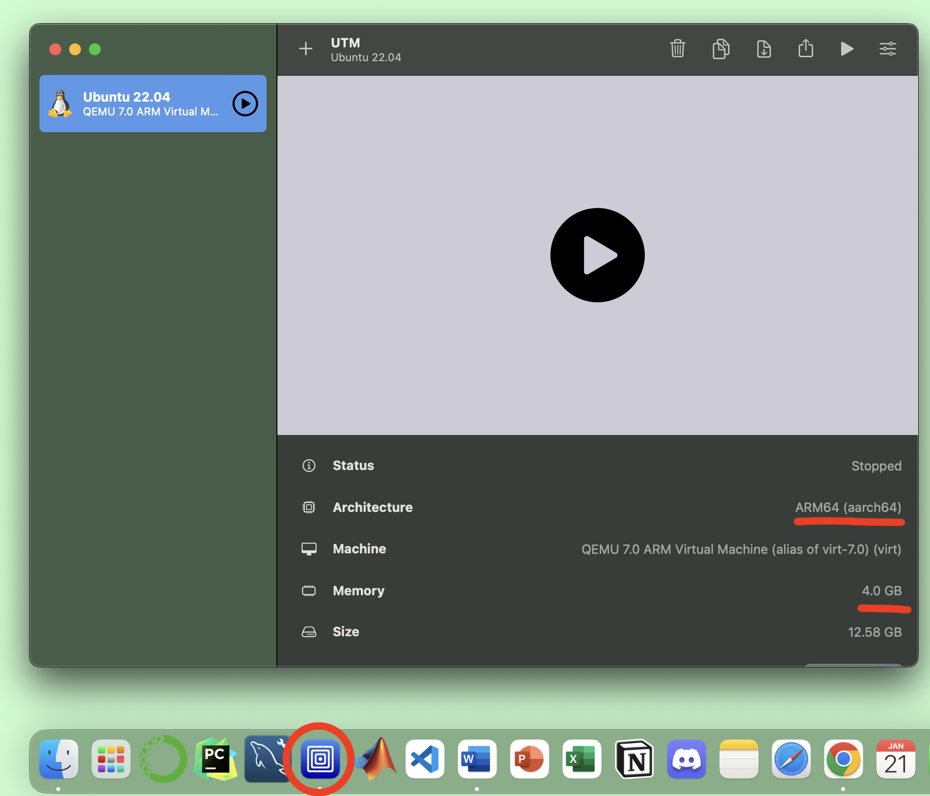

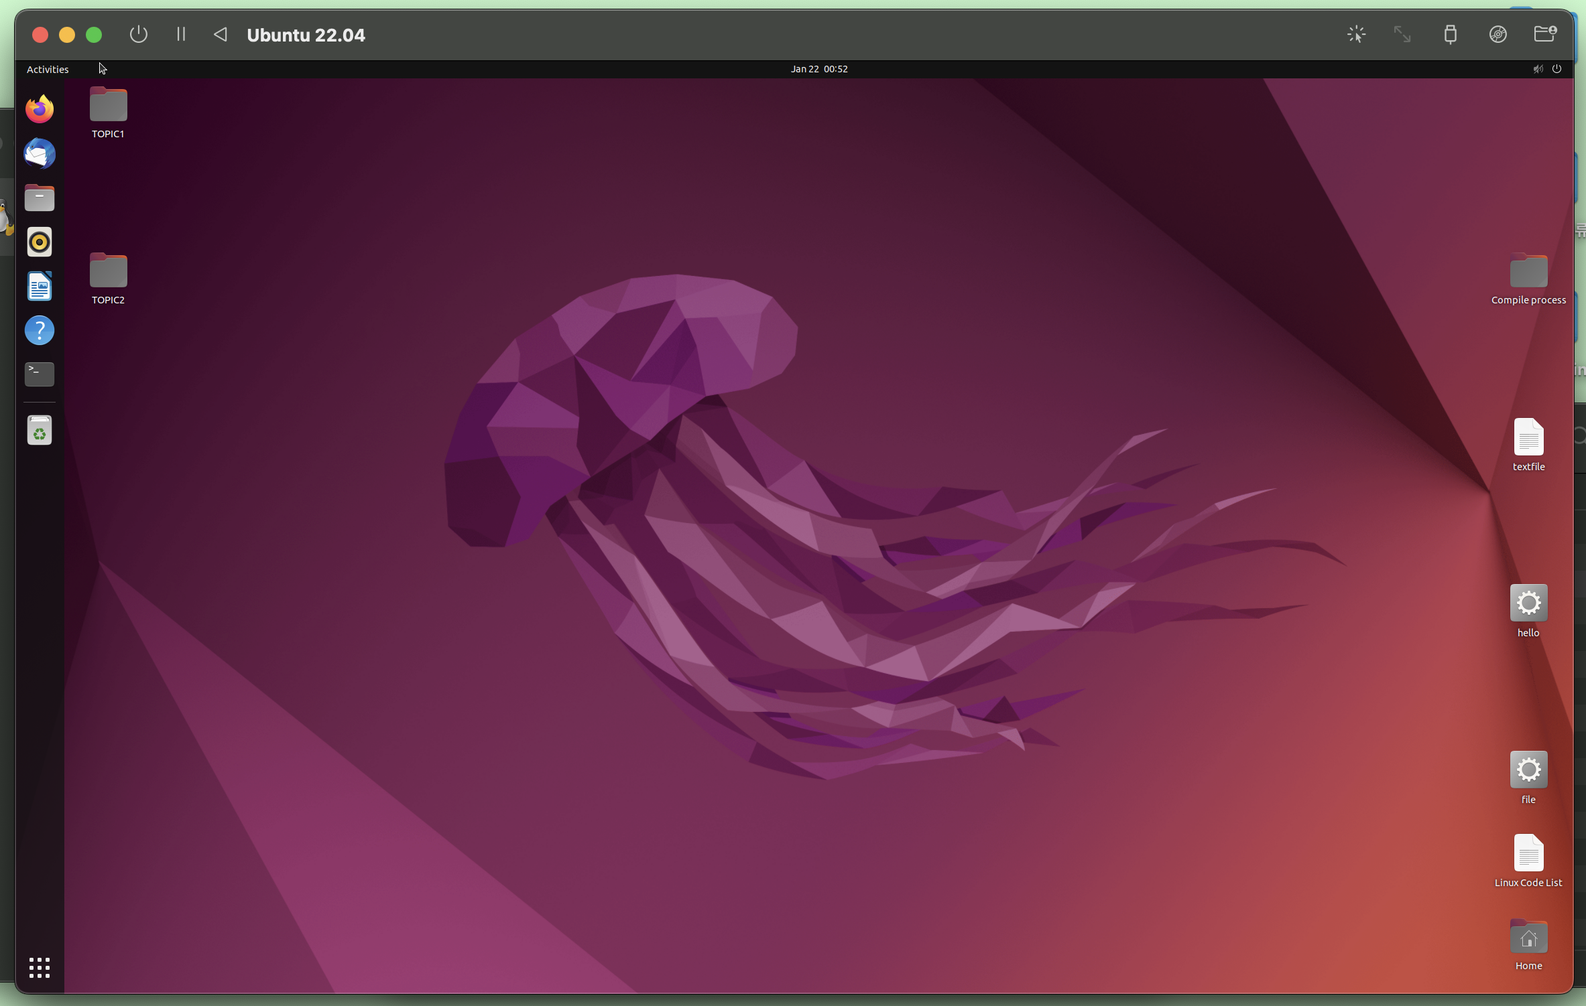

**Simple Program Compiling**

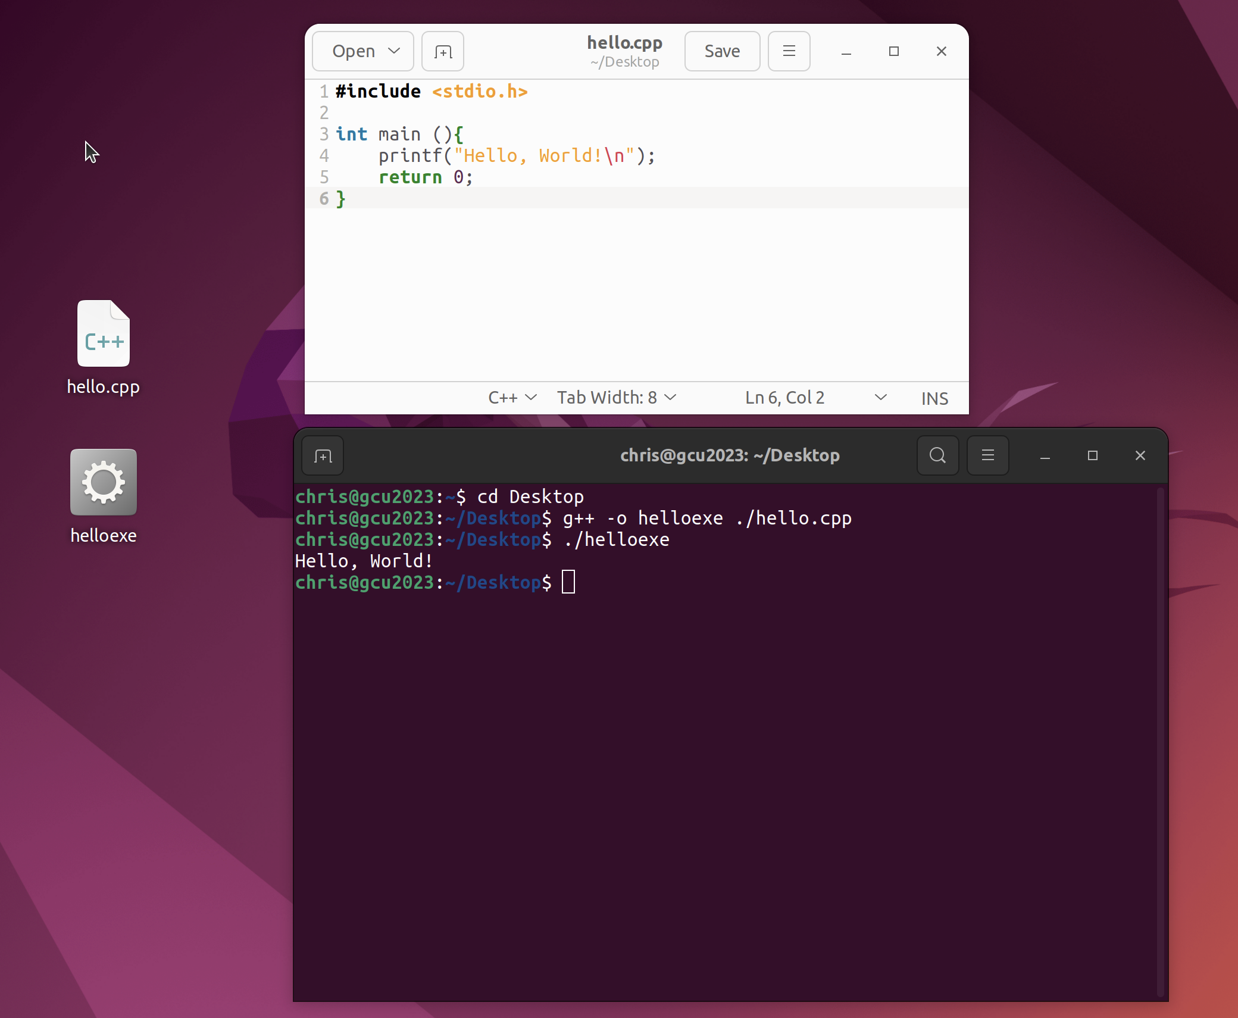

**PART 2: Linux Commands Exercises**

1. whoami - print the user name associated with the current effective user ID.

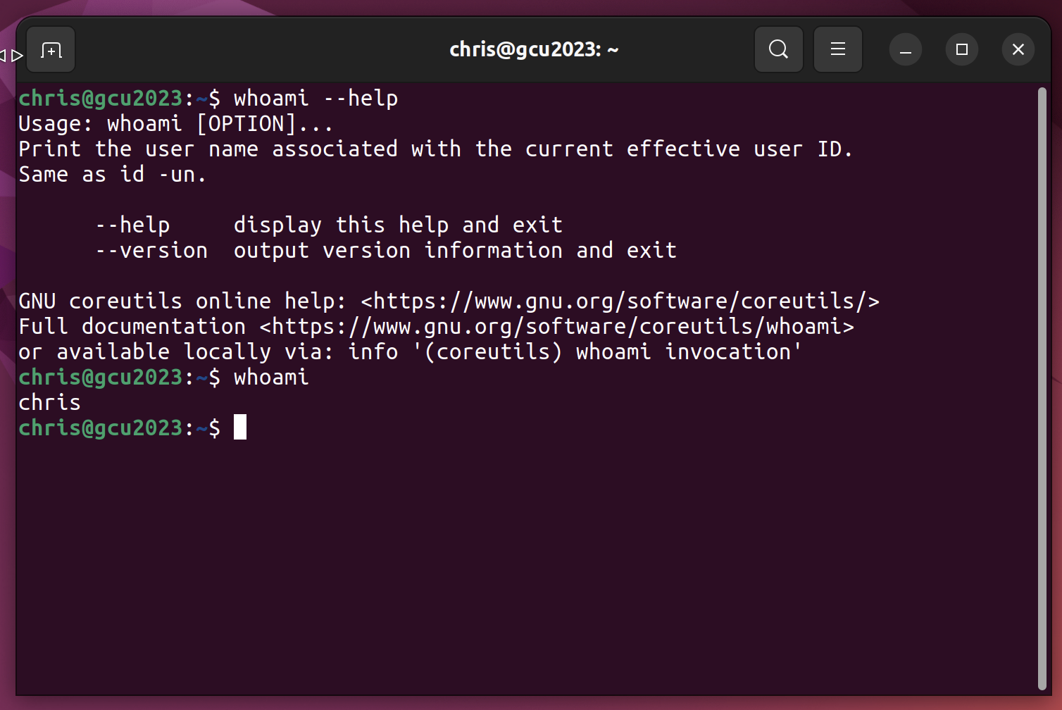

1. users – output who is currently logged in according to FILE.

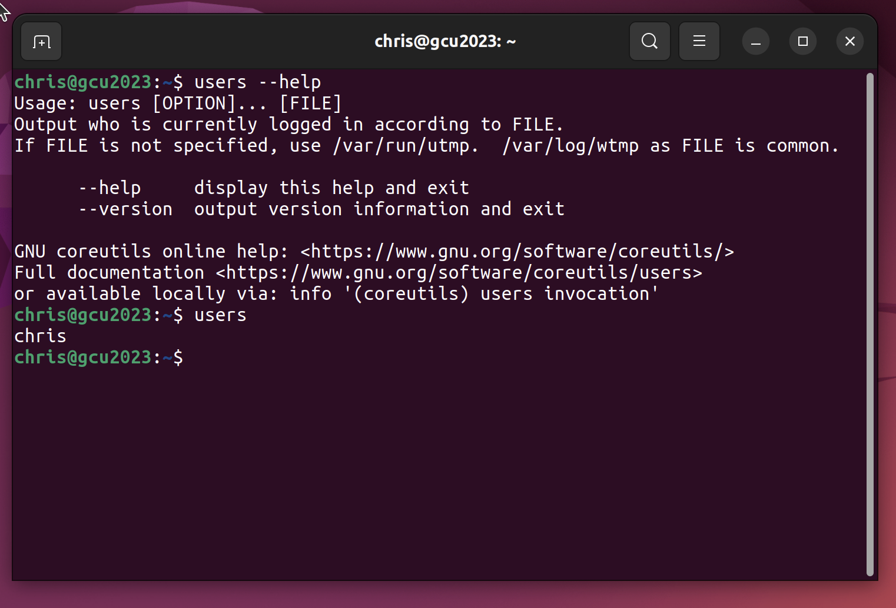

1. ls - The ls command in Linux is used to list the files of a given directory.
   1. ls -path : To list all the files and folders in a particular directory, the path of this directory is input as the first argument to the ls command.
   2. ls -r : The -R argument is used to recursively list down all the folders and files in all the directories and sub-directories of the system.
   3. ls / : The / argument is used to list all files and folders in the root directory.

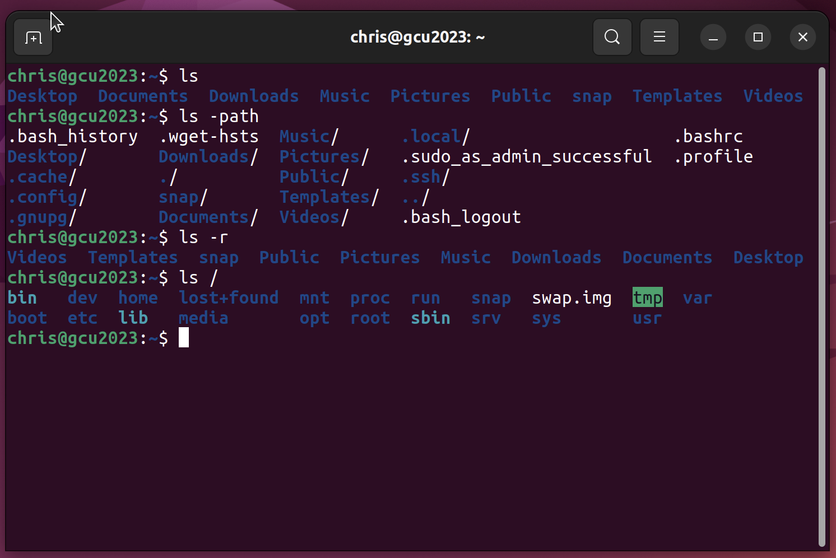

1. change *r,w,x* permission to a file using *chmod* – linux command for changing the mode for the file (read, write, execute). the syntax for chmod is :

chmod <options> <permissions> <file name>

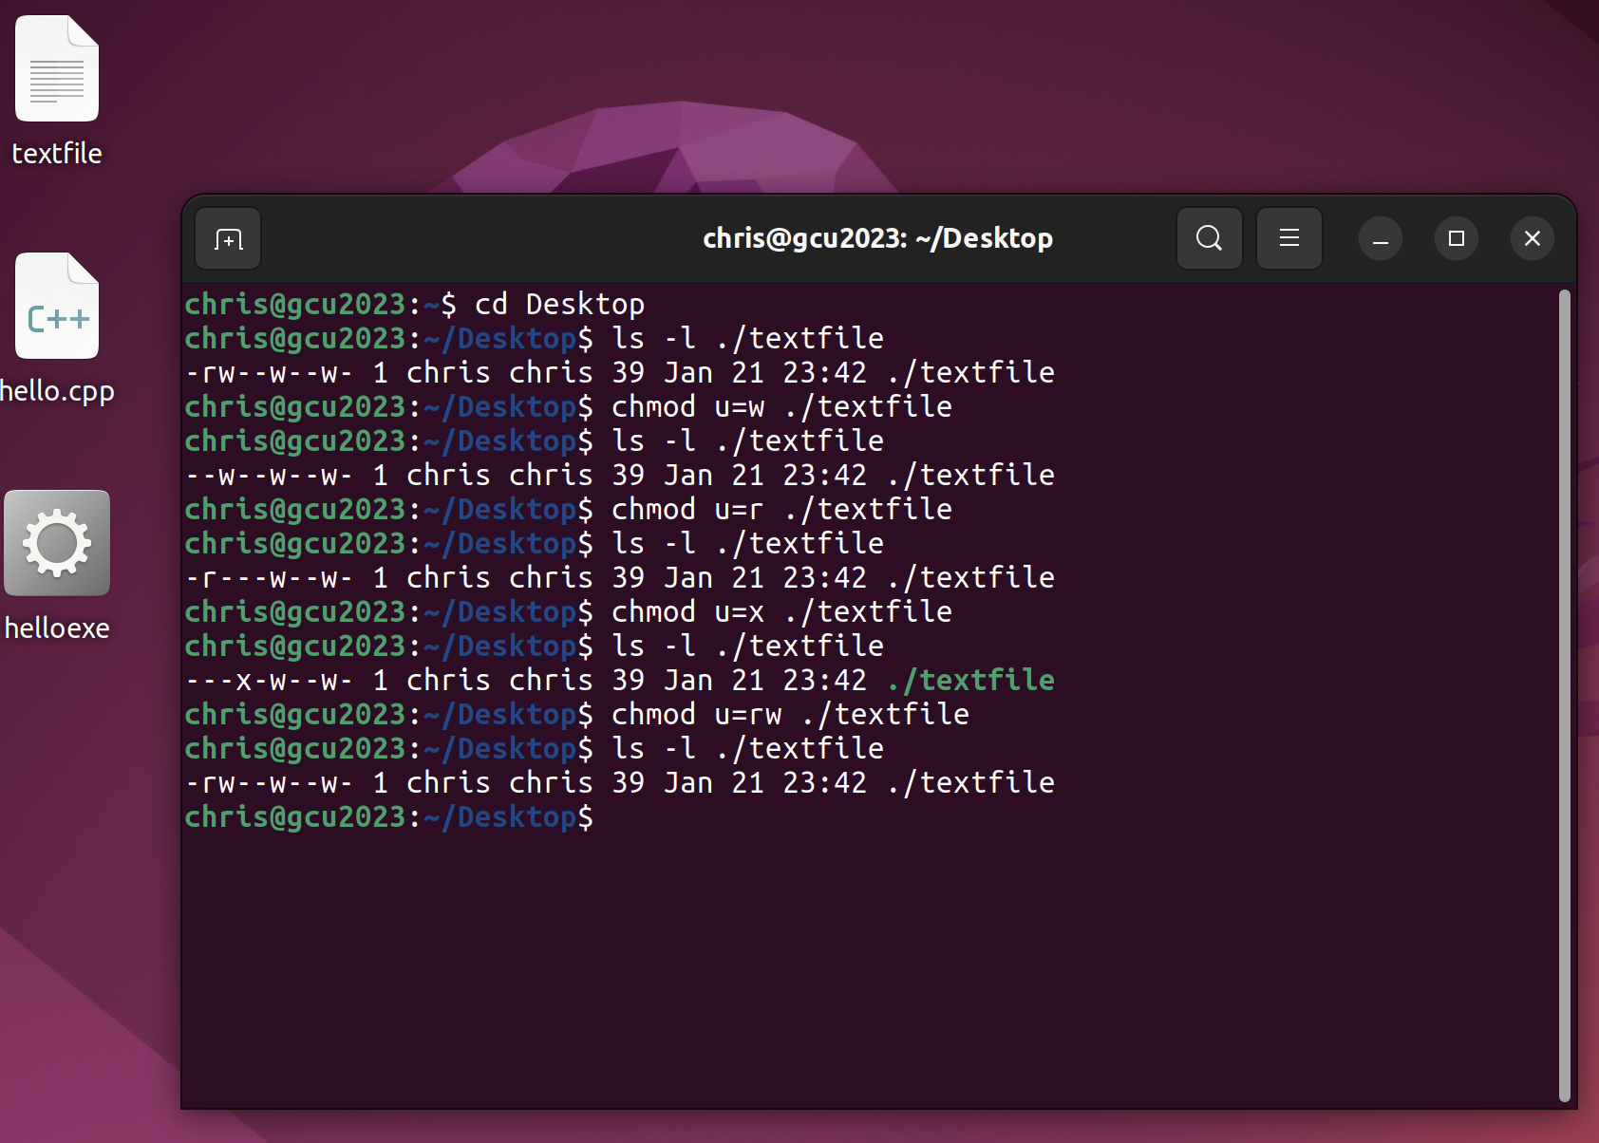

1. Check the value of any 3 environment variables

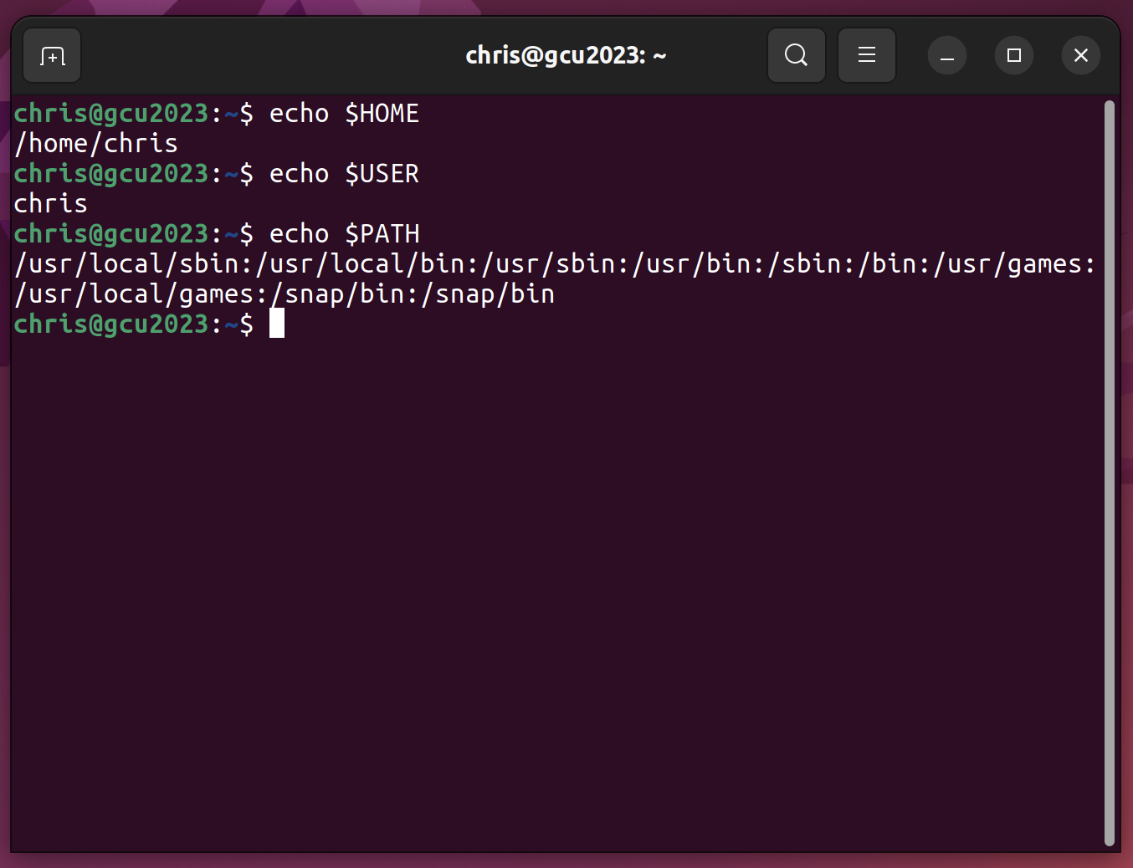

1. Use *grep* to search for specific content in a file

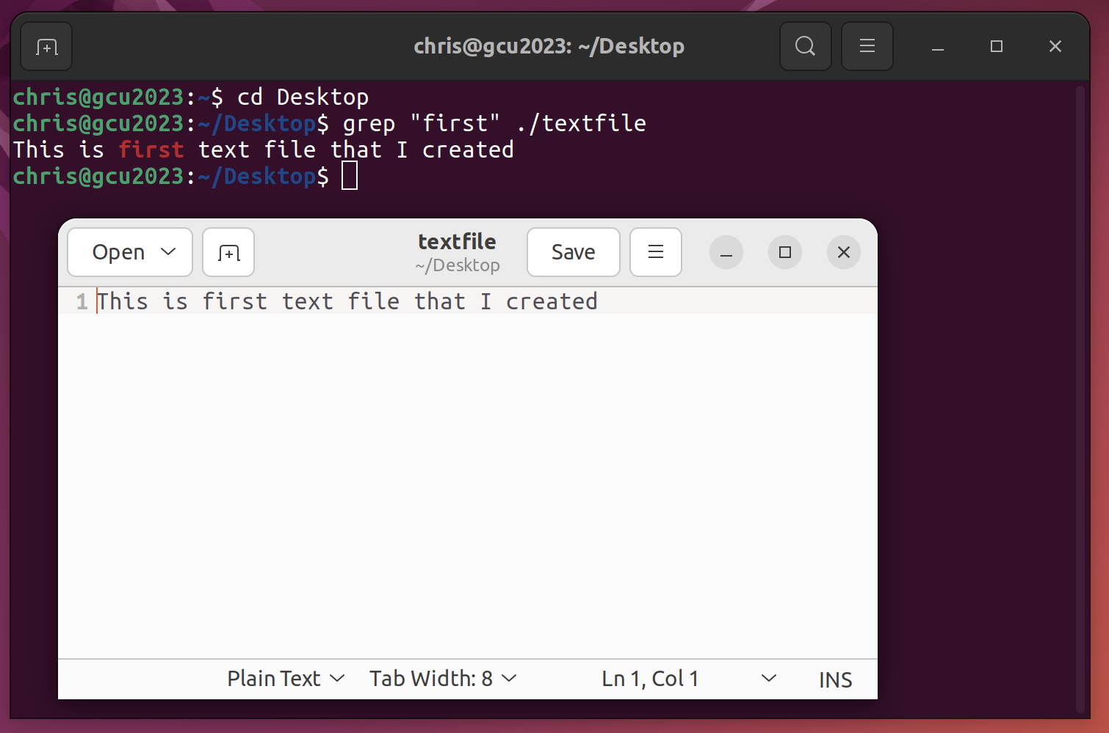

1. Use *sort, grep*, and *piping* to find a string in a list of files in a directory

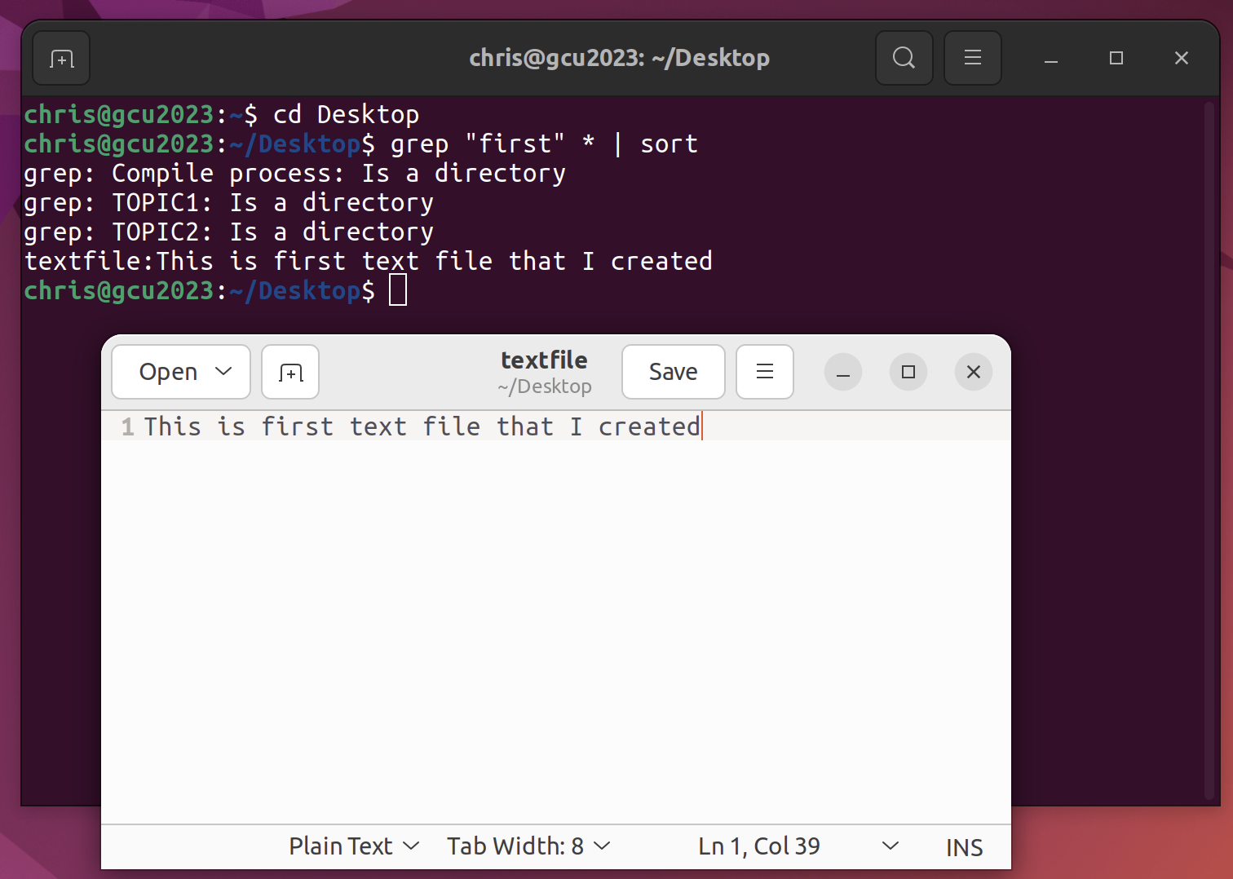

1. Explore the super user account and explain when and how it would be used

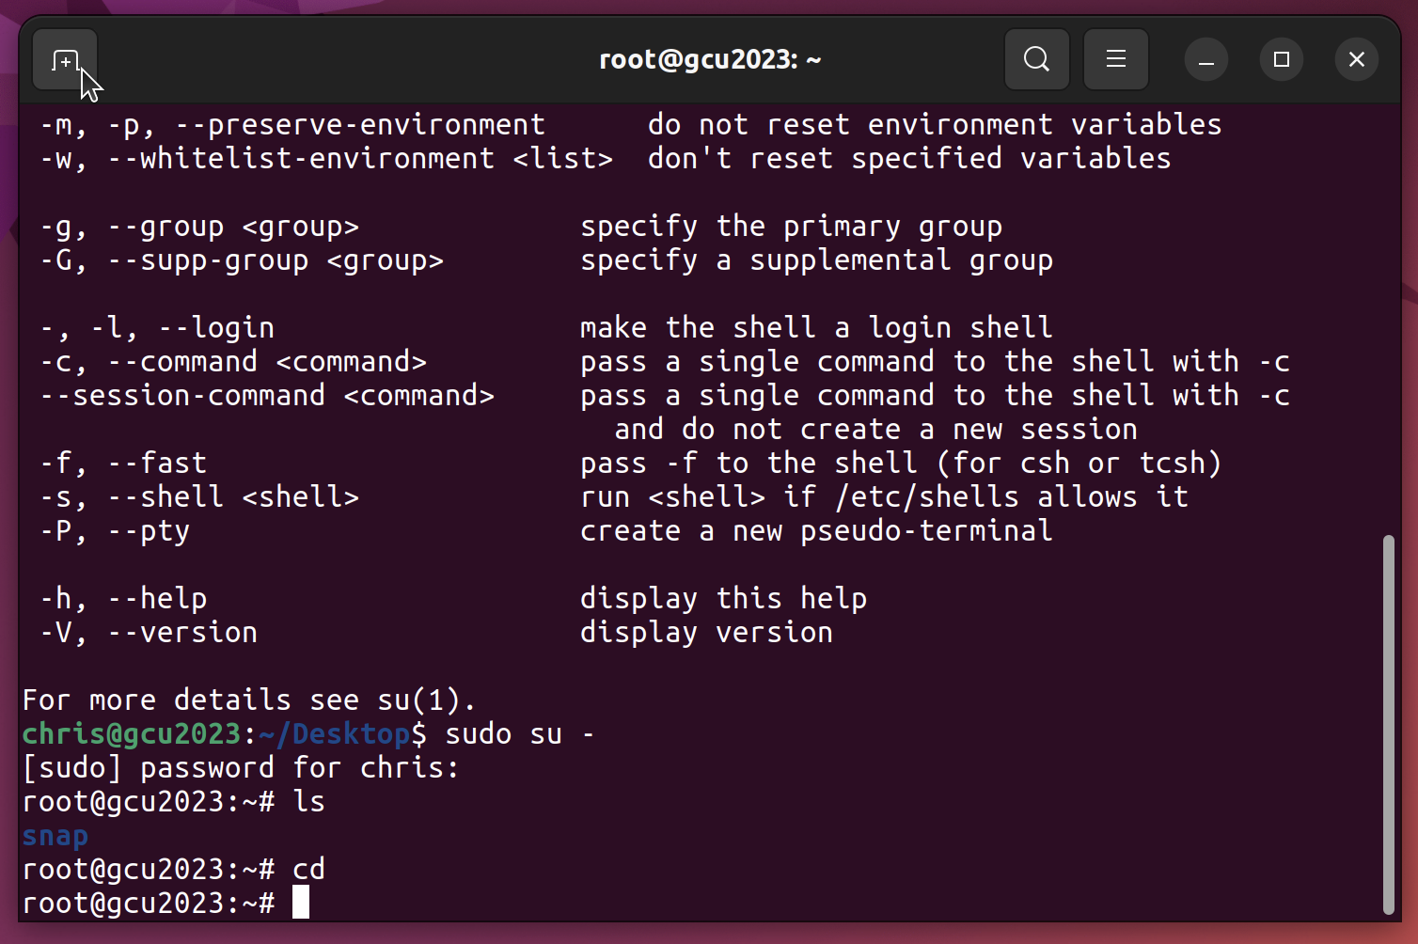

The super user account, also known as the root account, is used for system-level tasks such as installing software and changing system settings. It should be used with caution and only by experienced users, as it could make changes that can cause the system to become unstable or even inoperable.

1. Use the Linux/UNIX built-in manual and identify five additional, distinct, useful commands. Execute them and capture the result (IBM Documentation, 2020).

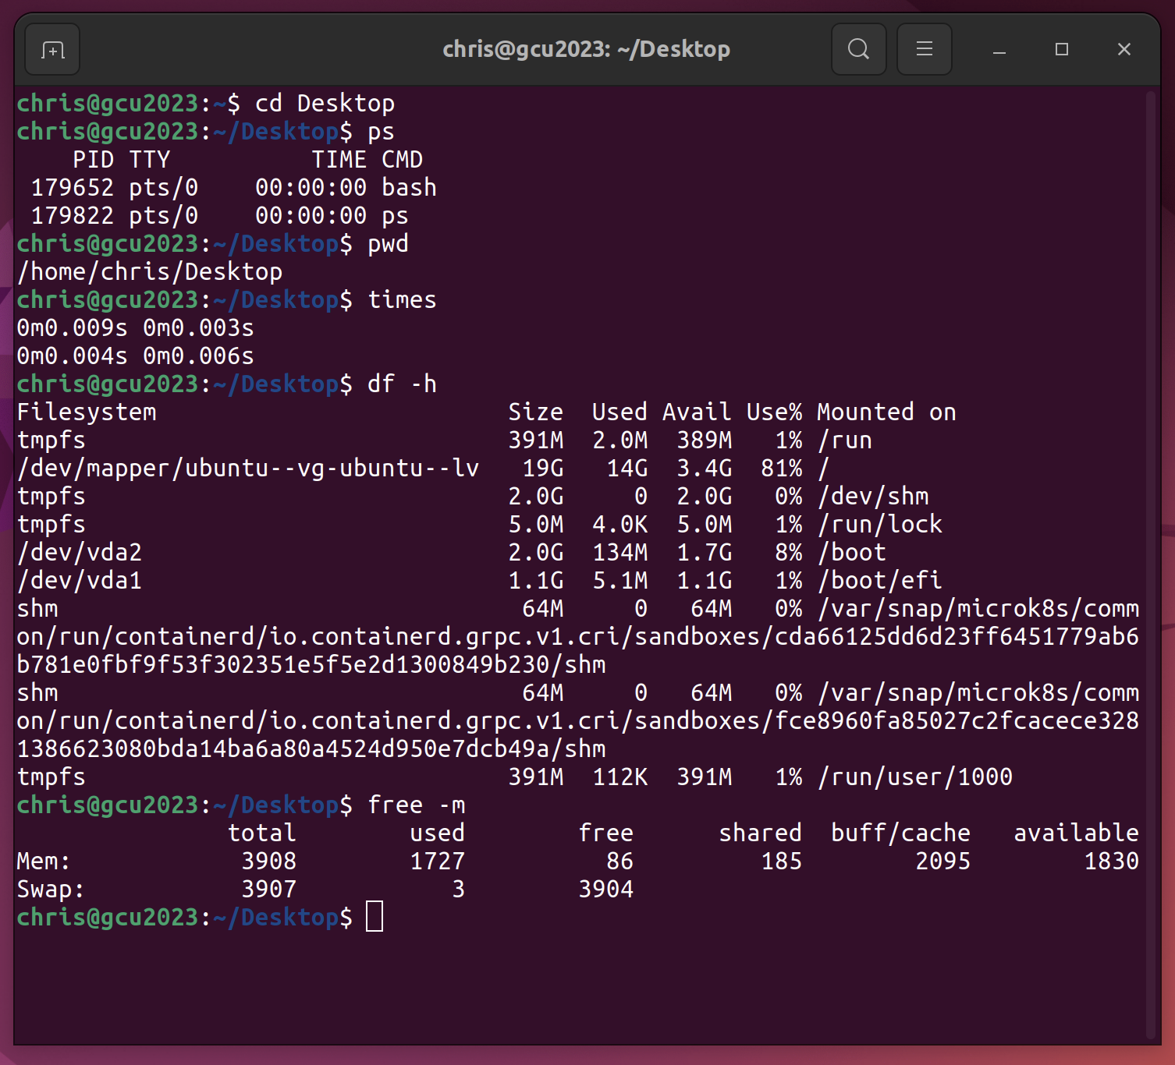

ps: Shows what process is running currently.

pwd: Shows the current directory

times: Displays the accumulated user and system times for processes run from the shell.

free: shows memory usage

df: shows disk free space

10.Create a shell script *test.sh* with five different UNIX/Linux commands of your choosing, execute it, and show the results.

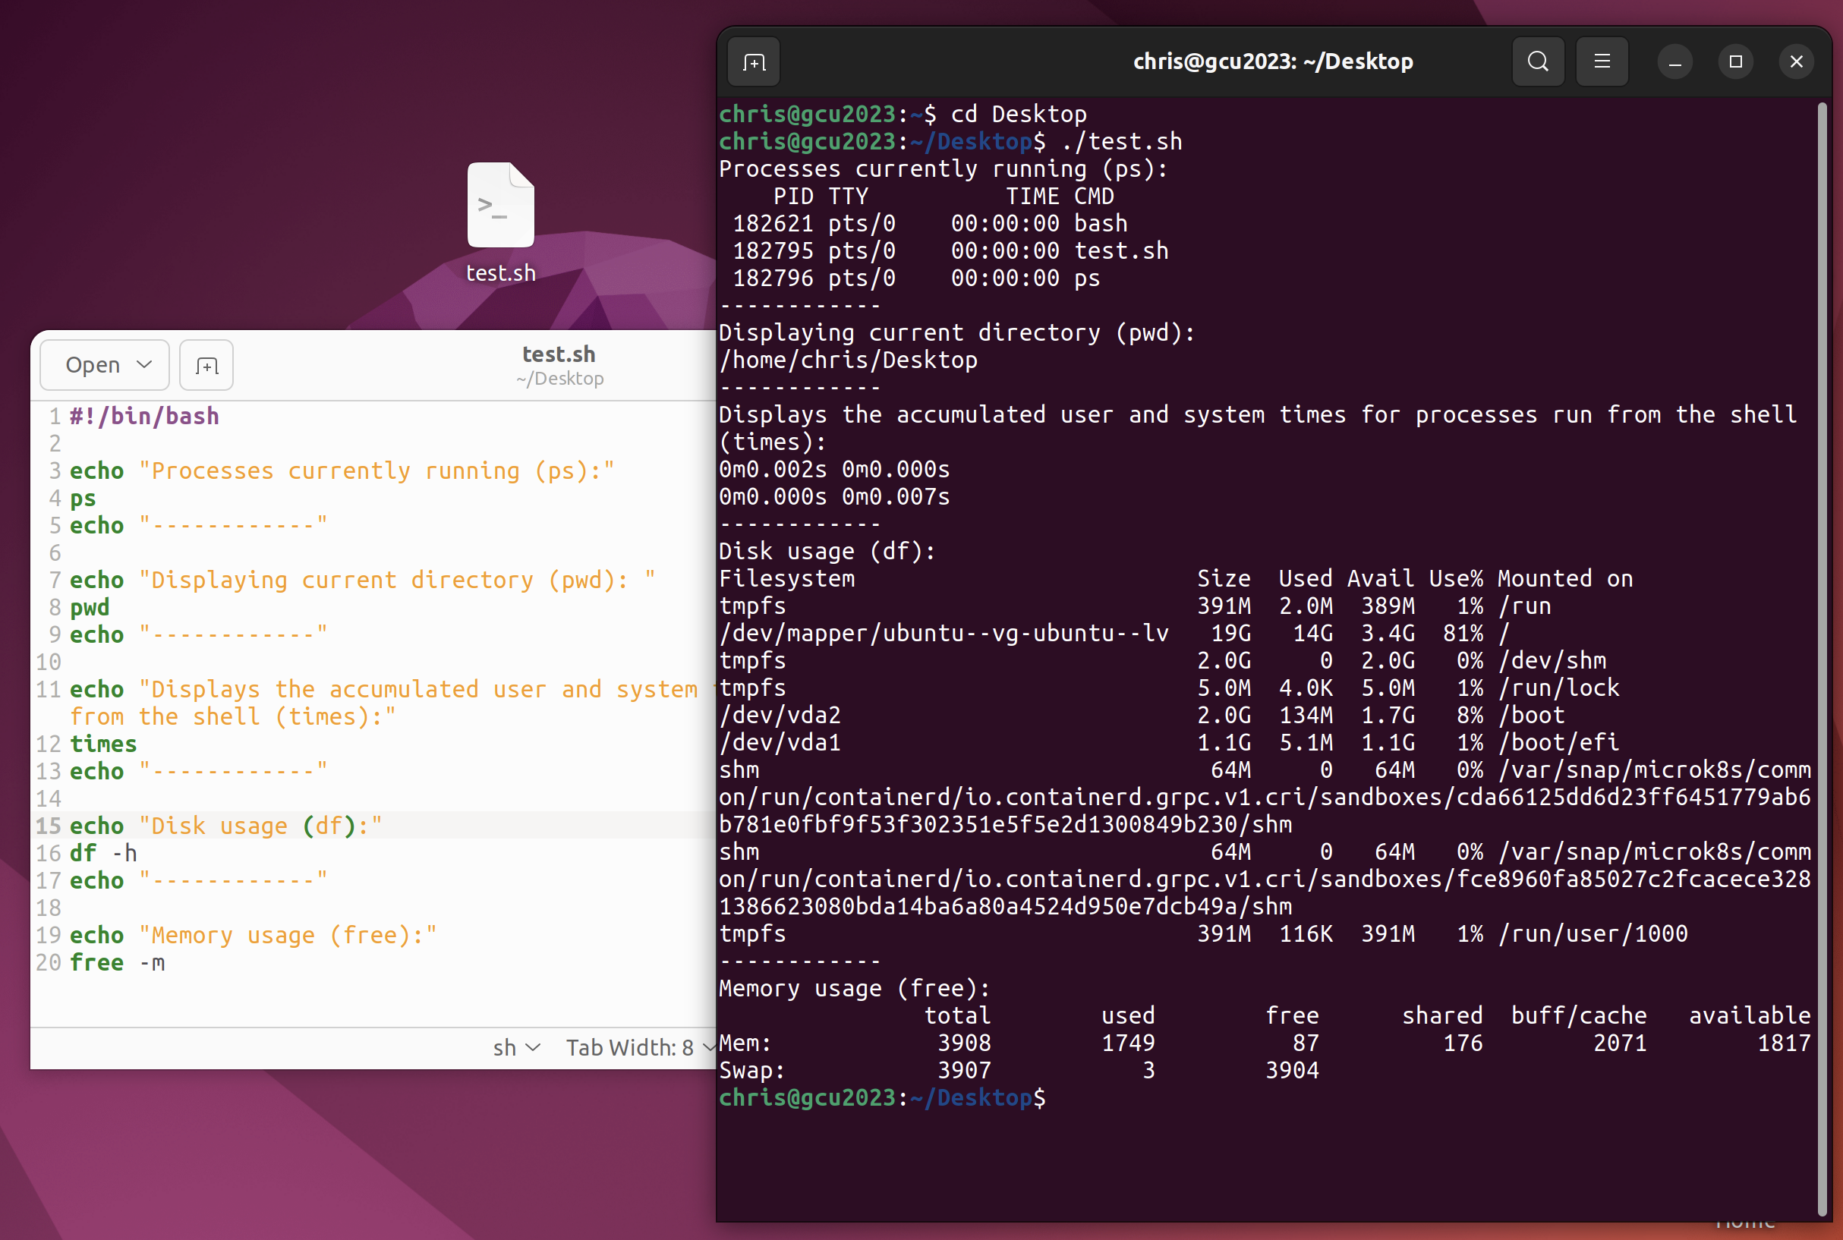

**References**

Abraham Silberschatz, Greg Gagne, and Peter Baer Galvin, "Operating System Concepts, Eighth Edition ", Chapter 13 (figure 13.6)

IBM Documentation (2020). List of Bourne shell built-in commands. Retrieved from https://www.ibm.com/docs/da/aix/7.1?topic=shell-list-bourne-built-in-commands